App.xaml.cs:

public static uchebkaEntities db = new uchebkaEntities();//метод подключения бд

Admin.cs:

public string GetPhoto

{

get

{

if (photo_admin is null)//вывод фото

{ return Directory.GetCurrentDirectory() + @"\Images\Лого ТНС.jpg"; }

return Directory.GetCurrentDirectory() + @"\Images\" + photo_admin.Trim();

}

}

public string GetRole

{

Get//разделения на роли

{

if (id_dolgj == 1)

{

return "Руководитель по работе с клиентами";

}

else if (id_dolgj == 2)

{

return "Руководитель отдела технической поддержки";

}

else if (id_dolgj== 3)

{

return "Специалист ТП (выездной инженер)";

}

else if (id_dolgj == 4)

{

return "Директор по развитию";

}

else if (id_dolgj == 5)

{

return "Технический департамент";

}

else if (id_dolgj == 6)

{

return "Бухгалтер";

}

else if (id_dolgj == 7)

{

return "Менеджер по работе с клиентами";

}

else

{

return "пользователь";

}

}

}

Captha.cs:

public static Drawing DrawMyText(string captcha)

{

//функция генерации капчи

Random rnd = new Random();

DrawingGroup drawingGroup = new DrawingGroup();

using (DrawingContext drawingContext = drawingGroup.Open())

{

FormattedText formattedText = new FormattedText(

captcha,

CultureInfo.GetCultureInfo("en-us"),//язык

FlowDirection.LeftToRight,

new Typeface("Times New Roman Bold"),//шрифт

18,

System.Windows.Media.Brushes.Black

);

Geometry textGeometry = formattedText.BuildGeometry(new System.Windows.Point(20, 0));

drawingContext.DrawGeometry(System.Windows.Media.Brushes.Black, new System.Windows.Media.Pen(System.Windows.Media.Brushes.Black, 1.5), textGeometry);

drawingContext.DrawLine(new System.Windows.Media.Pen(System.Windows.Media.Brushes.White, 4), new System.Windows.Point(rnd.Next(0, (int)formattedText.Width), rnd.Next(0, (int)formattedText.Height)), new System.Windows.Point(rnd.Next(0, (int)formattedText.Width), rnd.Next(0, (int)formattedText.Height)));

drawingContext.DrawLine(new System.Windows.Media.Pen(System.Windows.Media.Brushes.White, 4), new System.Windows.Point(rnd.Next(0, (int)formattedText.Width), rnd.Next(0, (int)formattedText.Height)), new System.Windows.Point(rnd.Next(0, (int)formattedText.Width), rnd.Next(0, (int)formattedText.Height)));

drawingContext.DrawLine(new System.Windows.Media.Pen(System.Windows.Media.Brushes.White, 4), new System.Windows.Point(rnd.Next(0, (int)formattedText.Width), rnd.Next(0, (int)formattedText.Height)), new System.Windows.Point(rnd.Next(0, (int)formattedText.Width), rnd.Next(0, (int)formattedText.Height)));

for (int i = 0; i < 10; i++)

{

drawingContext.DrawEllipse(System.Windows.Media.Brushes.Black, new System.Windows.Media.Pen(System.Windows.Media.Brushes.White, 4), new System.Windows.Point(rnd.Next(0, (int)formattedText.Width + 50), rnd.Next(0, (int)formattedText.Height)), 0.0001, 0.0001);

}

return drawingGroup;

}

}

Class1.cs:

static public bool IsAuth { get; set; } = false;

static public admin admin { get; set; }

LoginWindows.xaml:

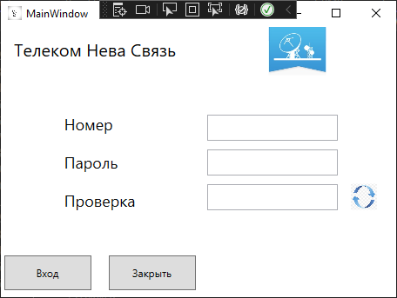

<Grid.RowDefinitions>

<RowDefinition Height="*"></RowDefinition>

<RowDefinition Height="200"></RowDefinition>

<RowDefinition Height="*"></RowDefinition>

</Grid.RowDefinitions>

<Grid.ColumnDefinitions>

<ColumnDefinition Width="*"></ColumnDefinition>

<ColumnDefinition Width="*"></ColumnDefinition>

</Grid.ColumnDefinitions>

<Label Content="Телеком Нева Связь" Grid.Row="0" Grid.Column="0" VerticalAlignment="Center" HorizontalAlignment="Left" Margin="10 0" FontSize="20" FontFamily="Time New Roman"/>

<Image Source="/Image/Лого ТНС.jpg" Grid.Row="0" Grid.Column="1"/>

<StackPanel Grid.Row="1" VerticalAlignment="Center" HorizontalAlignment="Center">

<Label Content="Номер" Margin="10 5 " FontSize="18"/>

<Label Content="Пароль" Margin="10 5 " FontSize="18"/>

<Label Content="Проверка" Margin="10 5 " FontSize="18"/>

</StackPanel>

<StackPanel Grid.Row="1" Grid.Column="1" VerticalAlignment="Center" HorizontalAlignment="Left">

<StackPanel Orientation="Horizontal">

<TextBox x:Name="TBNumber" Height="30" Width="150" Margin="10 5"/>

<Label/>

</StackPanel>

<StackPanel Orientation="Horizontal">

<PasswordBox Name="TBPassword" Height="30" Width="150" Margin="10 5"/>

<Label/>

</StackPanel>

<StackPanel Orientation="Horizontal">

<TextBox x:Name="TBCode" Height="30" Width="150" Margin="10 5"/>

<Image Source="/Image/На авторизацию_Обновление кода.jpg" Height="30" Width="40" />

</StackPanel>

</StackPanel>

<StackPanel Grid.Row="2" HorizontalAlignment="Center" VerticalAlignment="Center" Orientation="Horizontal">

<Button x:Name="BtnOpen" Content="Вход" Width="100" Height="40" Click="BtnOpen_Click" Margin="10 0"/>

<Button Name="BtnClose" Content="Закрыть" Width="100" Height="40" Click="BtnClose_Click" Margin="10 0"/>

</StackPanel>

LoginWindows.xaml.cs:

public MainWindow()

{

InitializeComponent();

}

private void BtnClose_Click(object sender, RoutedEventArgs e)

{

this.Close();

}

private void BtnOpen_Click(object sender, RoutedEventArgs e)

{

try

{//капча

CapthaWindows capthaWindows = new CapthaWindows();

bool isCorrect = (bool)capthaWindows.ShowDialog();

if (isCorrect)

{

admin admin = App.db.admin.FirstOrDefault(u => u.id_admin == TBNumber.Text && TBPassword.Password == "1111");//проверка логина и пароля

if (admin != null)

{

Class1.IsAuth = true;

Class1.admin = admin;

if (admin.id_dolgj == 1)

{

MainWindows mainWindows = new MainWindows();

mainWindows.Show();

this.Close();

}

else if (admin.id_dolgj == 2)

{

MainWindows mainWindows = new MainWindows();

mainWindows.Show();

this.Close();

}

else if (admin.id_dolgj == 3)

{

MainWindows mainWindows = new MainWindows();

mainWindows.Show();

this.Close();

}

else if (admin.id_dolgj == 4)

{

MainWindows mainWindows = new MainWindows();

mainWindows.Show();

this.Close();

}

else if (admin.id_dolgj == 5)

{

MainWindows mainWindows = new MainWindows();

mainWindows.Show();

this.Close();

}

else if (admin.id_dolgj == 6)

{

MainWindows mainWindows = new MainWindows();

mainWindows.Show();

this.Close();

}

else if (admin.id_dolgj == 7)

{

MainWindows mainWindows = new MainWindows();

mainWindows.Show();

this.Close();

}

else

{

MainWindows mainWindows = new MainWindows();

mainWindows.Show();

this.Close();

}

}

}

}

catch (Exception ex) { MessageBox.Show(ex.Message);

}

}

CapthaWindow.xaml:

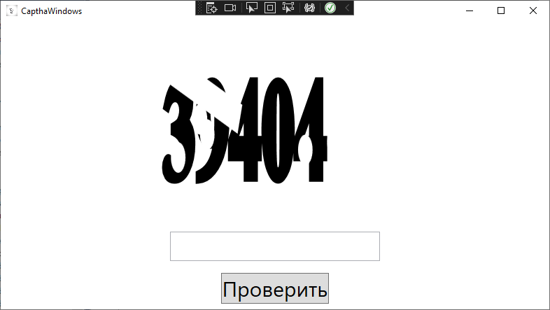

<Grid.RowDefinitions>

<RowDefinition Height="*"/>

<RowDefinition Height="60"/>

<RowDefinition Height="60"/>

</Grid.RowDefinitions>

<Grid x:Name="CaptchaImage" Width="450" Height="250"/>

<TextBox Name="CaptchaTb" Grid.Row="1" VerticalAlignment="Center" FontSize="30" Width="300"/>

<Button Name="CheckCaptcha" Click="CheckCaptcha_Click" Content="Проверить" Grid.Row="2" HorizontalAlignment="Center" VerticalAlignment="Center" FontSize="30" />

</Grid>

CapthaWindow.xaml.cs:

string _correctCaptcha { get; set; }

public bool _isCorrect { get; set; } = false;

public CapthaWindows()

{

InitializeComponent();

string abc = "1234567890";//символы которые участвуют в капче

string captcha = "";

Random rnd = new Random();

for (int i = 0; i < 5; i++)

{

captcha = captcha + abc[rnd.Next(0, abc.Length)];

}

_correctCaptcha = captcha;

CaptchaImage.Background = new DrawingBrush(Captha.DrawMyText(captcha));

}

private void CheckCaptcha_Click(object sender, RoutedEventArgs e)

{

if (_correctCaptcha != CaptchaTb.Text)

{

this.DialogResult = false;

MessageBox.Show("Капча введена неверно");

return;

}

MessageBox.Show("Начинайте работу!");

this.DialogResult = true;

}

MainWindows.xaml:

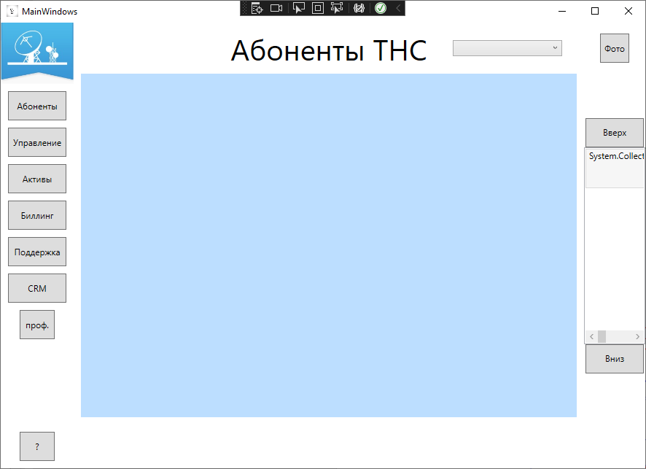

<Grid>

<Frame x:Name="Main"/><!--вывод страниц-->

</Grid>

MainWindows.xaml.cs:

ublic class links

{

public Button name { get; set; }

public Page link { get; set; }

}

public class zapisi

{

public string name { get; set; }

}

public MainWindows()

{

InitializeComponent();

Main.Navigate(new Pages.PageStart());

}

PageStart.xaml:



<Grid.ColumnDefinitions>

<ColumnDefinition Width="100"></ColumnDefinition>

<ColumnDefinition Width="700"></ColumnDefinition>

<ColumnDefinition Width="*"></ColumnDefinition>

</Grid.ColumnDefinitions>

<StackPanel>

<Image Source="/image/Лого ТНС.jpg" Grid.Row="1" RenderTransformOrigin="1.623,0.452"/>

<Button x:Name="AbonentBtn" Content="Абоненты" Margin="0 10 0 0" Click="AbonentBtn_Click" Width="80" Height="40"/>

<Button x:Name="UprBtn" Content="Управление" Height="40" Width="80" Margin="0 10 0 0" Click="UprBtn_Click"/>

<Button x:Name="ActBtn" Content="Активы" Height="40" Width="80" Margin="0 10 0 0" Click="ActBtn_Click"/>

<Button x:Name="BilBtn" Content="Биллинг" Height="40" Width="80" Margin="0 10 0 0" Click="BilBtn_Click"/>

<Button x:Name="PodBtn" Content="Поддержка" Height="40" Width="80" Margin="0 10 0 0" Click="PodBtn_Click"/>

<Button x:Name="CrmBtn" Content="CRM" Height="40" Width="80" Margin="0 10 0 0" Click="CrmBtn_Click"/>

<Button x:Name="ProfBtn" Content="проф." Margin="0 10" Click="ProfBtn_Click" Width="48" Height="40"/>

</StackPanel>

<Button x:Name="VoprBtn" Content="?" Margin="0 10" Click="VoprBtn_Click" Width="48" Height="40" VerticalAlignment="Bottom"/>

<Grid Grid.Column="1" Margin="10 0">

<Grid.RowDefinitions>

<RowDefinition Height="70"></RowDefinition>

<RowDefinition Height="*"></RowDefinition>

<RowDefinition Height="70"></RowDefinition>

</Grid.RowDefinitions>

<TextBlock x:Name="TextBlock" FontSize="40" Grid.Column="1" Grid.Row="0" VerticalAlignment="Center" HorizontalAlignment="Center">Абоненты ТНС</TextBlock>

<ComboBox Name="PolzCmb" Text="ФИО_пользователя" Width="150" Margin="20 0" SelectionChanged="PolzCmb_SelectionChanged" ItemsSource="{Binding client}" DisplayMemberPath="name" VerticalAlignment="Center" HorizontalAlignment="Right"/>

<Border Grid.Row="1" Opacity="0.3" Background="DodgerBlue">

<Frame x:Name="client"/>

</Border>

</Grid>

<Grid Grid.Column="2">

<Grid.RowDefinitions>

<RowDefinition Height="70"></RowDefinition>

<RowDefinition Height="*"></RowDefinition>

<RowDefinition Height="70"></RowDefinition>

</Grid.RowDefinitions>

<Button x:Name="Btn" Click="Btn_Click" Content="Фото" Height="40" Width="40" VerticalAlignment="Center" HorizontalAlignment="Center" Margin="10"/>

<Image x:Name="ImageClient"/>

<StackPanel Grid.Row="1" Orientation="Vertical" VerticalAlignment="Center" HorizontalAlignment="Center">

<Button Name="Btnup" Click="Btnup_Click" Width="80" Height="40" Content="Вверх"></Button>

<ListBox x:Name="events" Grid.Row="1" Grid.Column="1" Height="270" VerticalAlignment="Center" ScrollViewer.VerticalScrollBarVisibility="Disabled" SelectionChanged="events_SelectionChanged">

<ListBox.ItemTemplate>

<DataTemplate>

<Grid Height="50">

<TextBlock Text="{Binding name}"></TextBlock>

</Grid>

</DataTemplate>

</ListBox.ItemTemplate>

</ListBox>

<Button Name="BtnDown" Click="BtnDown_Click" Width="80" Height="40" Content="Вниз"></Button>

</StackPanel>

</Grid>

PageStart.xaml.cs:

public int cursor = 0;

public List<links> links = new List<links>();

public List<zapisi> zapisi = new List<zapisi>();

public void next(Button knopka)

{

var btns = AbonentBtn;

var linkThis = links.Where(x => x.name == knopka).FirstOrDefault();

btns = linkThis.name;

TextBlock.Text = (btns as Button).Content.ToString();

client.Navigate(linkThis.link);

}

public PageStart()

{

InitializeComponent();

PolzCmb.ItemsSource = App.db.admin.ToList();

links = new List<links> {

new links() { name = AbonentBtn, link = new Pages.ClientPage()},

new links() { name = UprBtn, link= new Pages.UprPage()},

new links() { name = ActBtn, link = new Pages.ActPage()},

new links() { name = BilBtn, link=new Pages.BilPtn()},

new links() { name = CrmBtn, link=new Pages.CRMPage(null)},

new links() { name = PodBtn, link=new Pages.PodPages()},

};

string b = Convert.ToString(App.db.info_admin.ToList());

zapisi = new List<zapisi>

{

new zapisi() {name=b},

};

events.ItemsSource = zapisi;

events.SelectedItem = zapisi[cursor];

}

private void PolzCmb_SelectionChanged(object sender, SelectionChangedEventArgs e)

{

}

private void Btn_Click(object sender, RoutedEventArgs e)

{

}

private void Btnup_Click(object sender, RoutedEventArgs e)

{

if (cursor != 0)

{

cursor--;

}

events.ScrollIntoView(zapisi[cursor]);

events.SelectedItem = zapisi[cursor];

}

private void BtnDown_Click(object sender, RoutedEventArgs e)

{

if (cursor != zapisi.Count - 1)

{

cursor++;

}

events.ScrollIntoView(zapisi[cursor]);

events.SelectedItem = zapisi[cursor];

}

private void VoprBtn_Click(object sender, RoutedEventArgs e)

{

}

private void AbonentBtn_Click(object sender, RoutedEventArgs e)

{

next(sender as Button);

}

private void UprBtn_Click(object sender, RoutedEventArgs e)

{

next(sender as Button);

}

private void ActBtn_Click(object sender, RoutedEventArgs e)

{

next(sender as Button);

}

private void BilBtn_Click(object sender, RoutedEventArgs e)

{

next(sender as Button);

}

private void PodBtn_Click(object sender, RoutedEventArgs e)

{

next(sender as Button);

}

private void CrmBtn_Click(object sender, RoutedEventArgs e)

{

next(sender as Button);

}

private void ProfBtn_Click(object sender, RoutedEventArgs e)

{

}

private void events_SelectionChanged(object sender, SelectionChangedEventArgs e)

{

}

ClientPage.xaml:

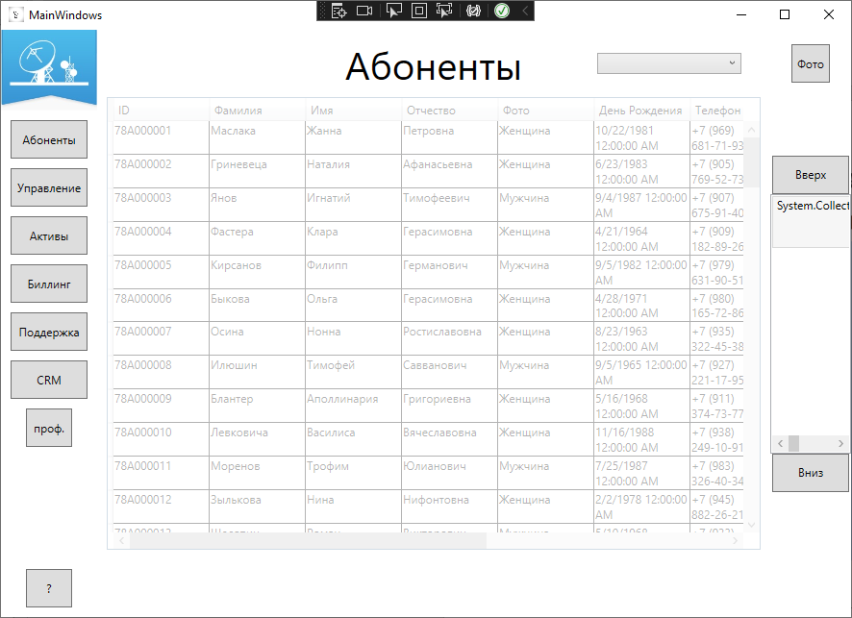

<DataGrid x:Name="DataTable" ItemsSource="{Binding name}" Background="White" ColumnWidth="100" HorizontalAlignment="Center" AutoGenerateColumns="False" Grid.Row="1">

<DataGrid.Columns>

<DataGridTemplateColumn Header="ID">

<DataGridTemplateColumn.CellTemplate>

<DataTemplate>

<TextBlock Text="{Binding id_client}" TextWrapping="Wrap"/>

</DataTemplate>

</DataGridTemplateColumn.CellTemplate>

</DataGridTemplateColumn>

<DataGridTemplateColumn Header="Фамилия">

<DataGridTemplateColumn.CellTemplate>

<DataTemplate>

<TextBlock Text="{Binding Surname}" TextWrapping="Wrap"/>

</DataTemplate>

</DataGridTemplateColumn.CellTemplate>

</DataGridTemplateColumn>

<DataGridTemplateColumn Header="Имя">

<DataGridTemplateColumn.CellTemplate>

<DataTemplate>

<TextBlock Text="{Binding name}" TextWrapping="Wrap"/>

</DataTemplate>

</DataGridTemplateColumn.CellTemplate>

</DataGridTemplateColumn>

<DataGridTemplateColumn Header="Отчество">

<DataGridTemplateColumn.CellTemplate>

<DataTemplate>

<TextBlock Text="{Binding patronimyc}" TextWrapping="Wrap"/>

</DataTemplate>

</DataGridTemplateColumn.CellTemplate>

</DataGridTemplateColumn>

<DataGridTemplateColumn Header="Фото">

<DataGridTemplateColumn.CellTemplate>

<DataTemplate>

<TextBlock Text="{Binding gender.name}" TextWrapping="Wrap"/>

</DataTemplate>

</DataGridTemplateColumn.CellTemplate>

</DataGridTemplateColumn>

<DataGridTemplateColumn Header="День Рождения">

<DataGridTemplateColumn.CellTemplate>

<DataTemplate>

<TextBlock Text="{Binding birthday}" TextWrapping="Wrap"/>

</DataTemplate>

</DataGridTemplateColumn.CellTemplate>

</DataGridTemplateColumn>

<DataGridTemplateColumn Header="Телефон">

<DataGridTemplateColumn.CellTemplate>

<DataTemplate>

<TextBlock Text="{Binding number_phone}" TextWrapping="Wrap"/>

</DataTemplate>

</DataGridTemplateColumn.CellTemplate>

</DataGridTemplateColumn>

<DataGridTemplateColumn Header="Почти">

<DataGridTemplateColumn.CellTemplate>

<DataTemplate>

<TextBlock Text="{Binding email}" TextWrapping="Wrap"/>

</DataTemplate>

</DataGridTemplateColumn.CellTemplate>

</DataGridTemplateColumn>

<DataGridTemplateColumn Header="Тип Контракта">

<DataGridTemplateColumn.CellTemplate>

<DataTemplate>

<TextBlock Text="{Binding contract_type.name}" TextWrapping="Wrap"/>

</DataTemplate>

</DataGridTemplateColumn.CellTemplate>

</DataGridTemplateColumn>

<DataGridTemplateColumn Header="Лицевой счет">

<DataGridTemplateColumn.CellTemplate>

<DataTemplate>

<TextBlock Text="{Binding lictev_chet}" TextWrapping="Wrap"/>

</DataTemplate>

</DataGridTemplateColumn.CellTemplate>

</DataGridTemplateColumn>

<DataGridTemplateColumn Header="Номер оборудования">

<DataGridTemplateColumn.CellTemplate>

<DataTemplate>

<TextBlock Text="{Binding number_oborud}" TextWrapping="Wrap"/>

</DataTemplate>

</DataGridTemplateColumn.CellTemplate>

</DataGridTemplateColumn>

</DataGrid.Columns>

</DataGrid>

ClientPage.xaml.cs:

public ClientPage()

{

InitializeComponent();

DataTable.ItemsSource = App.db.client.ToList();

}

CRMPPage.xaml:

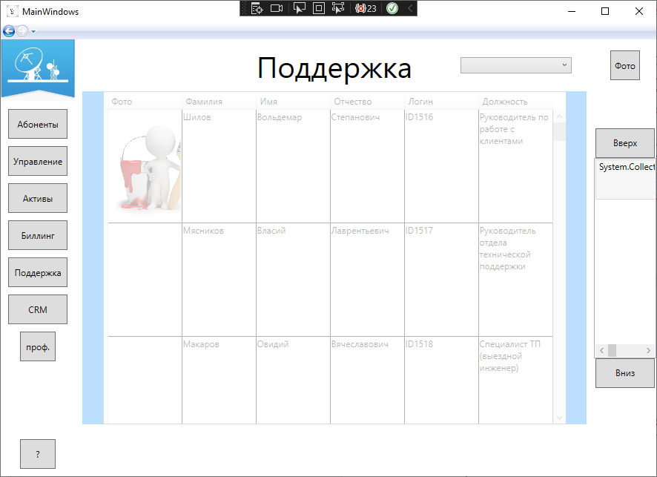

<Grid.RowDefinitions>

<RowDefinition></RowDefinition>

<RowDefinition></RowDefinition>

<RowDefinition></RowDefinition>

<RowDefinition></RowDefinition>

<RowDefinition></RowDefinition>

<RowDefinition></RowDefinition>

<RowDefinition></RowDefinition>

<RowDefinition></RowDefinition>

</Grid.RowDefinitions>

<Grid.ColumnDefinitions>

<ColumnDefinition></ColumnDefinition>

<ColumnDefinition></ColumnDefinition>

</Grid.ColumnDefinitions>

<TextBlock Text="ID Запроса" Height="40" Width="auto" Grid.Row="0" Margin="5 0"/>

<TextBlock Text="Услуга" Height="40" Width="auto" Grid.Row="1" Margin="5 0"/>

<TextBlock Text="Вид Услуги" Height="40" Width="auto" Grid.Row="2" Margin="5 0"/>

<TextBlock Text="Тип Услуги" Height="40" Width="auto" Grid.Row="3" Margin="5 0"/>

<TextBlock Text="Статус" Height="40" Width="auto" Grid.Row="4" Margin="5 0"/>

<TextBlock Text="Описание" Height="40" Width="auto" Grid.Row="5" Margin="5 0"/>

<TextBlock Text="Тип Проблемы" Height="40" Width="auto" Grid.Row="6" Margin="5 0"/>

<TextBox x:Name="TBID" Grid.Column="1" Grid.Row="0" Height="40" Width="350" Margin="5 0"/>

<ComboBox Name="CmbUsluga" Width="250" SelectionChanged="CmbUsluga_SelectionChanged_1" Grid.Column="1" Grid.Row="1" Height="40" ItemsSource="{Binding uslugaCRM}" DisplayMemberPath="name"/>

<ComboBox Name="CmbVidUslugi" Width="250" SelectionChanged="CmbVidUslugi_SelectionChanged" Grid.Column="1" Grid.Row="2" Height="40" ItemsSource="{Binding vid_uslugi}" DisplayMemberPath="name"/>

<ComboBox Name="CmbTypeUslugi" Width="250" SelectionChanged="CmbTypeUslugi_SelectionChanged" Grid.Column="1" Grid.Row="3" Height="40" ItemsSource="{Binding type_uslugi}" DisplayMemberPath="name"/>

<ComboBox Name="CmbStatus" Width="250" SelectionChanged="CmbStatus_SelectionChanged" Grid.Column="1" Grid.Row="4" Height="40" ItemsSource="{Binding Status}" DisplayMemberPath="name"/>

<TextBox x:Name="TBOpis" Grid.Column="1" Grid.Row="5" Height="40" Width="350" Margin="5 0"/>

<ComboBox Name="CmbTypeProblem" Width="250" SelectionChanged="CmbTypeProblem_SelectionChanged" Grid.Column="1" Grid.Row="6" Height="40" ItemsSource="{Binding type_problem}" DisplayMemberPath="name"/>

<Button x:Name="btnSave" Content="сохранить" Click="btnSave_Click" Grid.Row="10" Height="40" Width="80"/>

CRMPPage.xaml.cs:

private zayavka_CRM _currentGood = new zayavka_CRM();

public CRMPage(zayavka_CRM selectedGood)

{

InitializeComponent();

if (selectedGood != null)

{

List<zayavka_CRM> zayavka_CRMs = new List<zayavka_CRM>();

}

CmbUsluga.ItemsSource=App.db.uslugaCRM.ToList();

CmbTypeProblem.ItemsSource=App.db.type_problem.ToList();

CmbStatus.ItemsSource=App.db.status.ToList();

CmbTypeUslugi.ItemsSource=App.db.type_uslugi.ToList();

CmbVidUslugi.ItemsSource=App.db.vid_uslugi.ToList();

}

private void CmbUsluga_SelectionChanged(object sender, SelectionChangedEventArgs e)

{

}

private void CmbProblem_SelectionChanged(object sender, SelectionChangedEventArgs e)

{

}

private void CmbUsluga_SelectionChanged_1(object sender, SelectionChangedEventArgs e)

{

}

private void CmbVidUslugi_SelectionChanged(object sender, SelectionChangedEventArgs e)

{

}

private void CmbTypeUslugi_SelectionChanged(object sender, SelectionChangedEventArgs e)

{

}

private void CmbStatus_SelectionChanged(object sender, SelectionChangedEventArgs e)

{

}

private void CmbTypeProblem_SelectionChanged(object sender, SelectionChangedEventArgs e)

{

}

private void btnSave_Click(object sender, RoutedEventArgs e)

{

try

{

_currentGood.id_CRM = TBID.Text;

_currentGood.opisanie_problem = TBOpis.Text;

_currentGood.id_uslugaCRM = (CmbUsluga.SelectedItem as uslugaCRM).id_usligaCRM;

_currentGood.id_vid_uslugi = (CmbVidUslugi.SelectedItem as vid_uslugi).id_vid_uslugi;

_currentGood.id_status = (CmbStatus.SelectedItem as status).id_status;

_currentGood.id_type_problem = (CmbTypeProblem.SelectedItem as type_problem).id_type_problem;

_currentGood.id_type_uslugi = (CmbTypeUslugi.SelectedItem as type_uslugi).id_type_uslugi;

App.db.zayavka_CRM.Add(_currentGood);

App.db.SaveChanges();

MessageBox.Show("save");

NavigationService.Navigate(new Pages.ClientPage());

}

catch (Exception ex) { MessageBox.Show(ex.Message); }

}

PodPages.xaml:

<DataGrid x:Name="DataTable" ItemsSource="{Binding AdminName}" Background="White" ColumnWidth="100" HorizontalAlignment="Center" AutoGenerateColumns="False" Grid.Row="1">

<DataGrid.Columns>

<DataGridTemplateColumn Header="Фото">

<DataGridTemplateColumn.CellTemplate>

<DataTemplate>

<Image Source="{Binding GetPhoto}" Height="150" Width="150" Stretch="Fill"/>

</DataTemplate>

</DataGridTemplateColumn.CellTemplate>

</DataGridTemplateColumn>

<DataGridTemplateColumn Header="Фамилия">

<DataGridTemplateColumn.CellTemplate>

<DataTemplate>

<TextBlock Text="{Binding surname}" TextWrapping="Wrap"/>

</DataTemplate>

</DataGridTemplateColumn.CellTemplate>

</DataGridTemplateColumn>

<DataGridTemplateColumn Header="Имя">

<DataGridTemplateColumn.CellTemplate>

<DataTemplate>

<TextBlock Text="{Binding name}" TextWrapping="Wrap"/>

</DataTemplate>

</DataGridTemplateColumn.CellTemplate>

</DataGridTemplateColumn>

<DataGridTemplateColumn Header="Отчество">

<DataGridTemplateColumn.CellTemplate>

<DataTemplate>

<TextBlock Text="{Binding patronimyc}" TextWrapping="Wrap"/>

</DataTemplate>

</DataGridTemplateColumn.CellTemplate>

</DataGridTemplateColumn>

<DataGridTemplateColumn Header="Логин">

<DataGridTemplateColumn.CellTemplate>

<DataTemplate>

<TextBlock Text="{Binding id_admin}" TextWrapping="Wrap"/>

</DataTemplate>

</DataGridTemplateColumn.CellTemplate>

</DataGridTemplateColumn>

<DataGridTemplateColumn Header="Должность">

<DataGridTemplateColumn.CellTemplate>

<DataTemplate>

<TextBlock Text="{Binding dolgjnost.name}" TextWrapping="Wrap"/>

</DataTemplate>

</DataGridTemplateColumn.CellTemplate>

</DataGridTemplateColumn>

</DataGrid.Columns>

</DataGrid>

PodPages.xaml.cs:

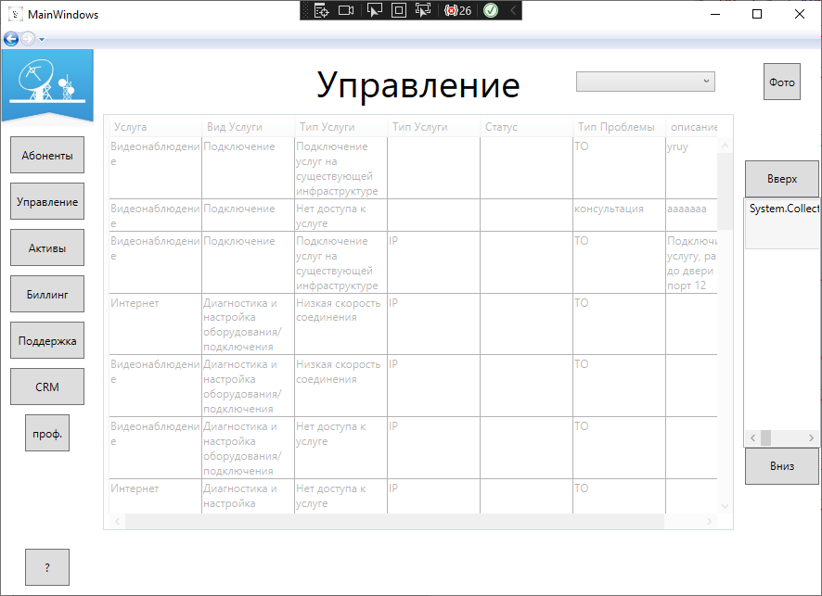

public PodPages()

{

InitializeComponent();

DataTable.ItemsSource = App.db.admin.ToList();

}

UprPage.xaml:

<DataGrid x:Name="DataTable" ItemsSource="{Binding id_CRM}" Background="White" ColumnWidth="100" HorizontalAlignment="Center" AutoGenerateColumns="False" Grid.Row="1">

<DataGrid.Columns>

<DataGridTemplateColumn Header="Услуга">

<DataGridTemplateColumn.CellTemplate>

<DataTemplate>

<TextBlock Text="{Binding uslugaCRM.name}" TextWrapping="Wrap"/>

</DataTemplate>

</DataGridTemplateColumn.CellTemplate>

</DataGridTemplateColumn>

<DataGridTemplateColumn Header="Вид Услуги">

<DataGridTemplateColumn.CellTemplate>

<DataTemplate>

<TextBlock Text="{Binding vid_uslugi.name}" TextWrapping="Wrap"/>

</DataTemplate>

</DataGridTemplateColumn.CellTemplate>

</DataGridTemplateColumn>

<DataGridTemplateColumn Header="Тип Услуги">

<DataGridTemplateColumn.CellTemplate>

<DataTemplate>

<TextBlock Text="{Binding type_uslugi.name}" TextWrapping="Wrap"/>

</DataTemplate>

</DataGridTemplateColumn.CellTemplate>

</DataGridTemplateColumn>

<DataGridTemplateColumn Header="Тип Услуги">

<DataGridTemplateColumn.CellTemplate>

<DataTemplate>

<TextBlock Text="{Binding type_oborud}" TextWrapping="Wrap"/>

</DataTemplate>

</DataGridTemplateColumn.CellTemplate>

</DataGridTemplateColumn>

<DataGridTemplateColumn Header="Статус">

<DataGridTemplateColumn.CellTemplate>

<DataTemplate>

<TextBlock Text="{Binding Status.name}" TextWrapping="Wrap"/>

</DataTemplate>

</DataGridTemplateColumn.CellTemplate>

</DataGridTemplateColumn>

<DataGridTemplateColumn Header="Тип Проблемы">

<DataGridTemplateColumn.CellTemplate>

<DataTemplate>

<TextBlock Text="{Binding type_problem.name}" TextWrapping="Wrap"/>

</DataTemplate>

</DataGridTemplateColumn.CellTemplate>

</DataGridTemplateColumn>

<DataGridTemplateColumn Header="описание проблемы">

<DataGridTemplateColumn.CellTemplate>

<DataTemplate>

<TextBlock Text="{Binding opisanie_problem}" TextWrapping="Wrap"/>

</DataTemplate>

</DataGridTemplateColumn.CellTemplate>

</DataGridTemplateColumn>

</DataGrid.Columns>

</DataGrid>

UprPage.xaml.cs:

public UprPage()

{

InitializeComponent();

DataTable.ItemsSource=App.db.zayavka_CRM.ToList();

}